**11. Using a terminal, connect to a remote machine via SSH and telnet**

**11.a.SSH:**

* It is a protocol that allows you to securely connect to a remote computer or a server using a text-based interface.
* It is the most common way to access remote Linux servers.
* It provides better protectinon from threats and malwares.

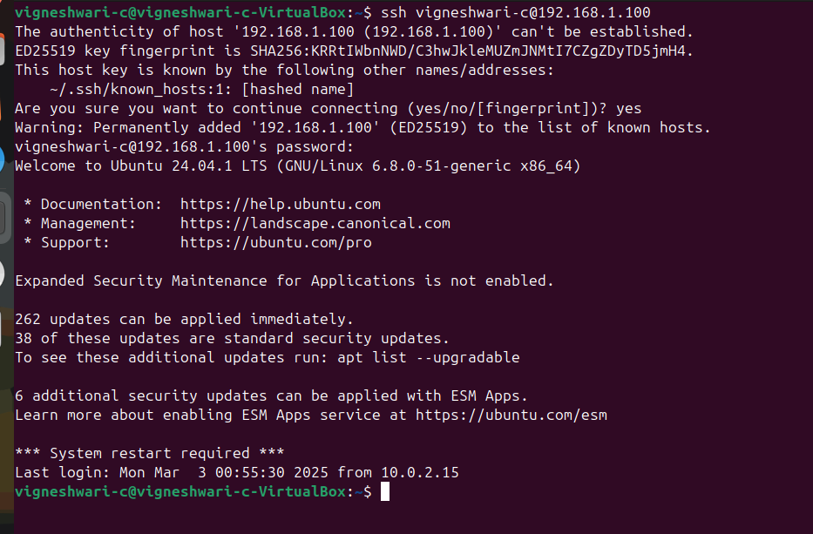

**11.b.TELNET:**

* Telnet is an older protocol that sends data in plain text instead of encrypted form.
* It posses high security risks.

